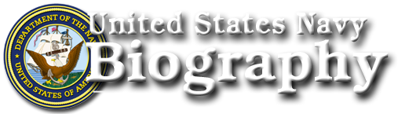
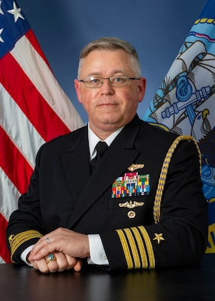
Download

Captain Matthew H. Welsh
Chief of Staff, U.S. Fleet Cyber Command / U.S. TENTH Fleet
Captain Matt Welsh was raised in a Marine Corps family. He graduated from the United States Naval Academy in 1993 with a Bachelor of Science degree in Systems Engineering. He received master’s degrees in engineering management from Old Dominion University and in national security and strategic studies from the Naval War College.
Following commissioning and completion of nuclear power and submarine training, he reported to the USS CAVALLA (SSN 684), where he qualified in submarines. Subsequent operational tours include Engineer Officer on USS SPRINGFIELD (SSN 761), submarine operations officer for Commander, Carrier Group FIVE embarked in USS KITTY HAWK (CV 63), and current operations officer for Commander, Submarine Group SEVEN.
After designation as an Information Professional in 2006, he served as Deputy Director, CJ6, for Commander, Joint Task Force Horn of Africa, Deputy Assistant Chief of Staff for C4I for Commander, Carrier Group TWELVE embarked in USS ENTERPRISE (CVN 65), Assistant Chief of Staff for C4I and Information Warfare Commander for Commander, Carrier Strike Group TEN embarked in USS DWIGHT D EISENHOWER (CVN 69), and Commanding Officer, Navy Computer and Telecommunications Station Far East/Commander Task Group 1010.7.
Shore tours include: flag lieutenant to Commander, Submarine Forces U.S. Pacific Fleet; Deputy Director, Next Generation Enterprise Network Fleet Implementation and Training Team, Navy Cyber Forces; and Director for C4I on the staff of Commander, Navy Expeditionary Combat Command.
Captain Welsh’s decorations include the Legion of Merit, Defense Meritorious Service Medal, Meritorious Service Medal, Navy and Marine Corps Commendation Medal, and Navy and Marine Corps Achievement Medal.

